LABOROTORIYA ISHI №13
Mavzu: REST API xizmat yaratish va so‘rov yuborish (PHP).
Ishning maqsadi
- REST arxitekturasining ishlash tamoyillarini o‘rganish.
- PHP yordamida JSON formatida ma'lumot qaytaruvchi API yaratish.
- CURL kutubxonasi yordamida tashqi API xizmatlariga so‘rov yuborish ko‘nikmalarini shakllantirish.
Nazariy qism
REST tushunchasi va falsafasi
REST (Representational State Transfer) — bu 2000-yilda Roy Fielding tomonidan taklif etilgan, taqsimlangan gipermedia tizimlari (masalan, Internet) uchun mo'ljallangan arxitektura uslubidir. REST alohida dasturiy mahsulot emas, balki veb-xizmatlar qanday loyihalashtirilishi kerakligini belgilovchi qoidalar va cheklovlar to'plamidir. REST tamoyillari asosida ishlovchi tizimlar RESTful tizimlar deb ataladi.
REST arxitekturasining 6 ta asosiy cheklovi
Tizim haqiqiy RESTful bo'lishi uchun quyidagi shartlarga javob berishi kerak:
- Client-Server (Mijoz-Server): Mijoz interfeys (frontend) uchun, server esa ma'lumotlarni saqlash va qayta ishlash (backend) uchun javobgar. Bu ularni bir-biridan mustaqil rivojlantirish imkonini beradi.
- Stateless (Holatsiz): Har bir so'rov (request) o'zida server tushunishi uchun kerakli barcha ma'lumotni saqlashi kerak. Server mijozning avvalgi so'rovlarini "eslab qolmaydi" (sessiyalar saqlanmaydi).
- Cacheable (Keshlanuvchi): Mijoz va server orasidagi tarmoq yuklamasini kamaytirish uchun server javoblari keshlanadigan bo'lishi (ya'ni ma'lum vaqt saqlab qo'yilishi) kerak.
- Uniform Interface (Yagona interfeys): Barcha resurslarga (masalan, /api/xiva/monuments) murojaat qilish usullari standartlashgan va bir xil formatda bo'lishi shart.
- Layered System (Ko'p qatlamli tizim): Mijoz serverga bog'lanayotganda, u to'g'ridan-to'g'ri oxirgi serverga yoki oraliq vositachiga (Proxy, Load Balancer) ulanayotganini bilmasligi kerak.
- Code on Demand (Ixtiyoriy): Server mijozga ijro etilishi mumkin bo'lgan kodlarni (masalan, JavaScript skriptlari) yuborishi mumkin (bu majburiy shart emas).
HTTP metodlari va ularning semantikasi
REST API resurslar ustida amallar bajarish uchun HTTP protokoli metodlaridan foydalanadi:
Metod | Tavsif | Idempotentlik
GET | Resurs haqida ma'lumot olish (faqat o'qish). | Ha
POST | Yangi resurs yaratish (masalan, yangi obida qo'shish). | Yo'q
PUT | Mavjud resursni to'liq yangilash. | Ha
PATCH | Resursning bir qismini o'zgartirish. | Yo'q
DELETE | Resursni o'chirish. | Ha
JSON va ma'lumotlar almashinuvi
RESTful xizmatlarda ma'lumotlar uzatish formati sifatida JSON tanlangan. JSON (JavaScript Object Notation) matnga asoslangan, inson o'qishi uchun qulay va kompyuterlar tomonidan tez qayta ishlanadigan formatdir. PHP tilida json_encode() funksiyasi massivni JSON matniga, json_decode() esa JSON matnini PHP ob'ektiga aylantirib beradi.
API xavfsizligi va Status kodlari
Har bir API so'roviga server HTTP status kodlari bilan javob qaytaradi:
- 200 OK: So'rov muvaffaqiyatli bajarildi.
- 201 Created: Yangi resurs yaratildi (POST).
- 400 Bad Request: Mijoz yuborgan so'rovda xatolik bor.
- 401 Unauthorized: Mijoz autentifikatsiyadan o'tmagan.
- 404 Not Found: So'ralgan resurs topilmadi.
- 500 Internal Server Error: Serverda kutilmagan xatolik yuz berdi.
Amaliy qism:
<!DOCTYPE html>
<html lang="uz">
<head>
<meta charset="UTF-8">
<meta name="viewport" content="width=device-width, initial-scale=1.0">
<title>REST API Simulyatori - Xiva City</title>
<!-- Google Fonts va Ikonkalar -->
<link href="https://fonts.googleapis.com/css2?family=Fira+Code:wght@400;500&family=Poppins:wght@300;400;600&display=swap" rel="stylesheet">
<link rel="stylesheet" href="https://cdnjs.cloudflare.com/ajax/libs/font-awesome/6.0.0/css/all.min.css">
<style>
:root {
--primary: #1a1a2e;
--secondary: #16213e;
--api-green: #4caf50;
--text-accent: #e94560;
}
body {
font-family: 'Poppins', sans-serif;
background-color: #f0f2f5;
margin: 0;
padding: 20px;
}
.api-container {
max-width: 900px;
margin: 20px auto;
background: white;
border-radius: 15px;
overflow: hidden;
box-shadow: 0 10px 30px rgba(0,0,0,0.1);
}
/* Yuqori qism */
.api-header {
background: var(--primary);
color: white;
padding: 30px;
text-align: center;
}
.api-header h1 { margin: 0; font-size: 1.8rem; }
.api-header p { margin: 10px 0 0; opacity: 0.8; }
.api-url-bar {
background: var(--secondary);
padding: 15px 30px;
display: flex;
align-items: center;
gap: 15px;
color: #fff;
font-family: 'Fira Code', monospace;
font-size: 0.9rem;
border-bottom: 1px solid #2a3a5a;
}
.method-get {
background: var(--api-green);
padding: 2px 10px;
border-radius: 4px;
font-weight: bold;
}
/* Asosiy bloklar */
.api-content {
padding: 30px;
display: flex;
gap: 25px;
}
.panel {
flex: 1;
padding: 20px;
border-radius: 12px;
}
/* Client paneli */
.request-panel {
background: #f8fbff;
border: 1px solid #e1e8f0;
}
.btn-fetch {
width: 100%;
background: var(--text-accent);
color: white;
border: none;
padding: 15px;
border-radius: 10px;
cursor: pointer;
font-weight: 600;
font-size: 1rem;
transition: 0.3s;
margin-top: 20px;
}
.btn-fetch:hover { background: #d63d58; transform: scale(1.02); }
/* Server paneli (JSON chiqadigan joy) */
.response-panel {
background: #272822;
color: #f8f8f2;
font-family: 'Fira Code', monospace;
min-height: 250px;
position: relative;
}
.status-badge {
position: absolute;
top: 15px;
right: 15px;
color: var(--api-green);
font-weight: bold;
display: none;
}
#jsonOutput {
margin-top: 15px;
white-space: pre-wrap;
line-height: 1.5;
}
.json-key { color: #f92672; }
.json-val { color: #e6db74; }
.json-num { color: #ae81ff; }
</style>
</head>
<body>
<div class="api-container">
<div class="api-header">
<h1><i class="fas fa-network-wired"></i> REST API Xizmati</h1>
<p>Xiva Tarixiy Obidalari Ma'lumotlar Bazasi</p>
</div>
<div class="api-url-bar">
<span class="method-get">GET</span>
<span>https://api.khiva.uz/v1/monuments</span>
</div>
<div class="api-content">
<!-- Client -->
<div class="panel request-panel">
<h3 style="margin-top:0"><i class="fas fa-paper-plane"></i> API So'rov (Client)</h3>
<p style="font-size: 0.9rem; color: #666;">Serverga so'rov yuboring va natijani kuting.</p>
<ul style="font-size: 0.8rem; color: #555; padding-left: 15px;">
<li>Header: application/json</li>
<li>Auth: Public Access</li>
</ul>
<button class="btn-fetch" onclick="runSimulation()">So'rov yuborish</button>
</div>
<!-- Server -->
<div class="panel response-panel">
<div id="status" class="status-badge">Status: 200 OK</div>
<h3 style="margin-top:0; border-bottom: 1px solid #444; padding-bottom: 10px;">
<i class="fas fa-server"></i> JSON Javob
</h3>
<div id="jsonOutput">// So'rov kutilmoqda...</div>
</div>
</div>
</div>
<script>
function runSimulation() {
const output = document.getElementById('jsonOutput');
const status = document.getElementById('status');
output.innerHTML = "Yuklanmoqda...";
status.style.display = "none";
setTimeout(() => {
status.style.display = "block";
output.innerHTML = `{\n <span class="json-key">"status"</span>: <span class="json-val">"success"</span>,\n <span class="json-key">"city"</span>: <span class="json-val">"Xiva"</span>,\n <span class="json-key">"data"</span>: {\n <span class="json-key">"id"</span>: <span class="json-num">77</span>,\n <span class="json-key">"name"</span>: <span class="json-val">"Ichan Qal'a"</span>,\n <span class="json-key">"is_unesco"</span>: <span class="json-num">true</span>\n }\n}`;
}, 600);
}
</script>
</body>
</html>
Natijasi:
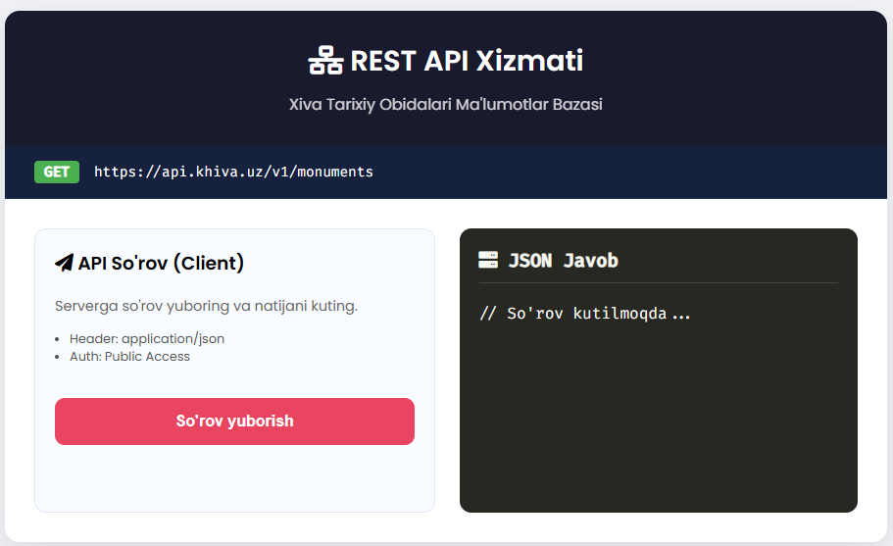
Xulosa:
Ushbu laboratoriya ishi davomida PHP tilida sodda REST API yaratish va undan ma'lumot olish jarayonlari o'rganildi.
JSON formatining afzalligi: Ma'lumotlarni tizimlararo uzatishda JSON juda qulay va ixcham format ekanligi tasdiqlandi.
CURL imkoniyatlari: PHP orqali nafaqat o'zimizning, balki dunyodagi istalgan (masalan, ob-havo yoki valyuta kurslari) API xizmatlariga ulanish mumkinligi ko'rildi.
Xavfsizlik: API yaratishda header() funksiyalari orqali ruxsatlarni (CORS) to'g'ri sozlash muhim ahamiyatga ega.
Xulosa qilib aytganda, REST API zamonaviy veb-texnologiyalarning (Frontend va Backend integratsiyasi) asosi hisoblanadi.

